**PROJECT REPORT**

**Student Name-** Luv Valecha

**Roll No.-** B23CM1022

**Project Name-** File Encryption System

File Encryption System provides user with a feature to secure their files by encrypting them with a 4-digit key that they make. The file can only be decrypted by that 4-digit key only.

The encryption works on **Vigenère cipher**, it accepts a 4-digit integer key, the file name and the key are stored in a structure which is stored in the database. The encryption technique subtracts the ASCII value of characters in the file with the digits of the key in a loop. For example- if the key id 1234, then the ASCII value of the first character of the file will be subtracted by 1, the ASCII value of the next character will be subtracted by 2, next by 3, next by 4 and then the next by 1 again and so on. Once file is decrypted, it also asks if the user want to read the file or not.

This system stores the structure of the key and the file name in a file named “Encryption_Database.txt”. This helps to check if the user has entered the correct key during decryption and stores the key values even if the code running has stopped.

It consists of a user-friendly menu and error messages to ensure smooth functioning of the system. Some screenshots:

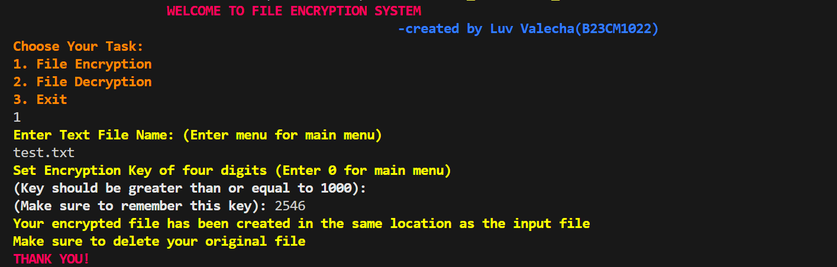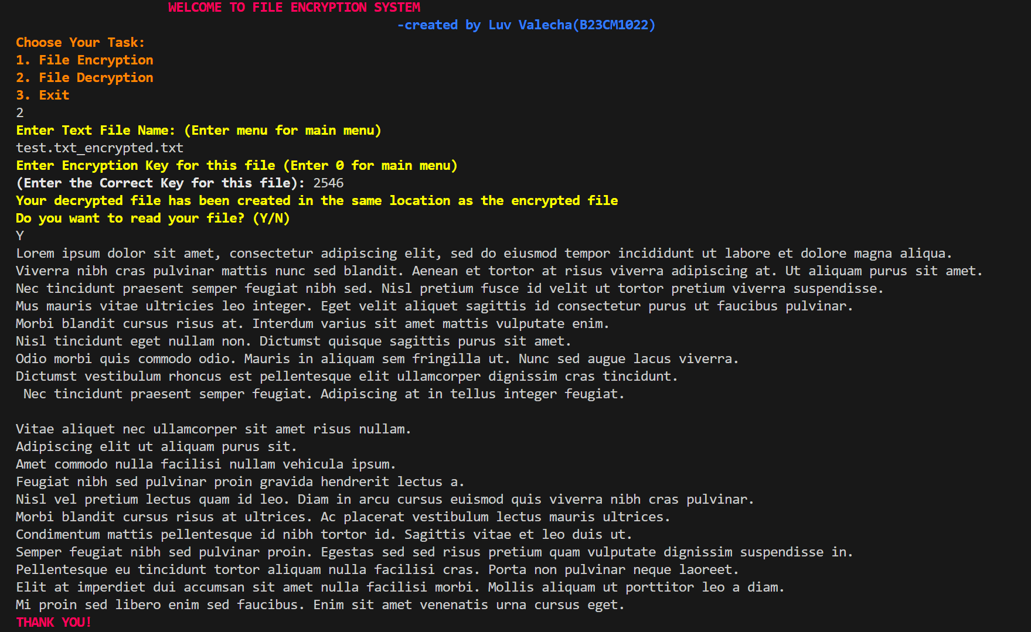

Encrypted file:

